**PRACTICAL 1**

**Write a program to draw the following using pre-defined functions in computer graphics:**

**1. Circle**

**2. Line**

**3. Rectangle**

**4. Arc**

**5. Ellipse**

**6. Polygon**

**Also, change the background colour.**

**Code:**

#include <graphics.h>

#include <conio.h>

void main() {

int gd = DETECT, gm;

int nose[] = {245, 210, 255, 210, 250, 230, 245, 210};

initgraph(&gd, &gm, "C:\\TURBOC3\\BGI");

outtextxy(10,10,"Harshit Lakhera 02214202023");

rectangle(80,50,420,320);

circle(250, 200, 100);

setfillstyle(SOLID_FILL, BROWN);

floodfill(250, 200, WHITE);

circle(210, 180, 15);

circle(290, 180, 15);

ellipse(250, 240, 200, 340, 60, 40);

arc(210, 165, 20, 160, 20); // Left brow

arc(290, 165, 20, 160, 20); // Right bro

drawpoly(4, nose);

line(195, 252, 305, 252);

getch();

closegraph();

}

**OUTPUT:**

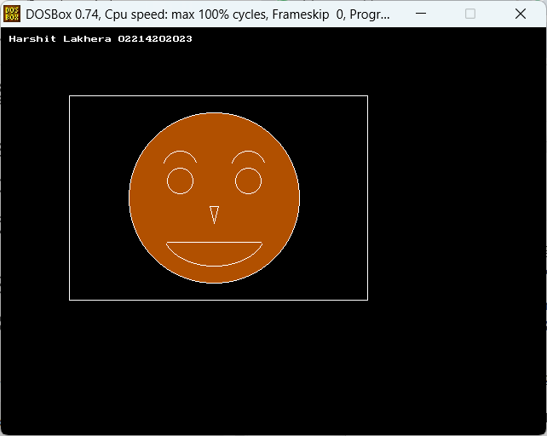

**PRACTICAL 2**

**Write a program to draw a moving Cycle/ Any other moving graphics image of your choice using Pre defined functions (basic shapes) in computer graphics**

**Code:**

#include <graphics.h>

#include <conio.h>

void main() {

int gd = DETECT, gm;

int x;

initgraph(&gd, &gm, "C:\\TURBOC3\\BGI");

for (x = 0; x < getmaxx(); x += 5) {

cleardevice();

outtextxy(10,10,"Harshit Lakhera 02214202023");

// Draw ground line below cycle

line(0, 340, getmaxx(), 340);

// Wheels

circle(x, 300, 30);

circle(x + 100, 300, 30);

// Frame (triangle style)

line(x, 300, x + 50, 250);

line(x + 50, 250, x + 100, 300);

line(x, 300, x + 100, 300);

// Handlebar

line(x + 100, 300, x + 110, 250);

// Seat

line(x + 40, 250, x + 60, 250);

if (kbhit()) break;

delay(40);

}

getch();

closegraph();

}

**OUTPUT:**

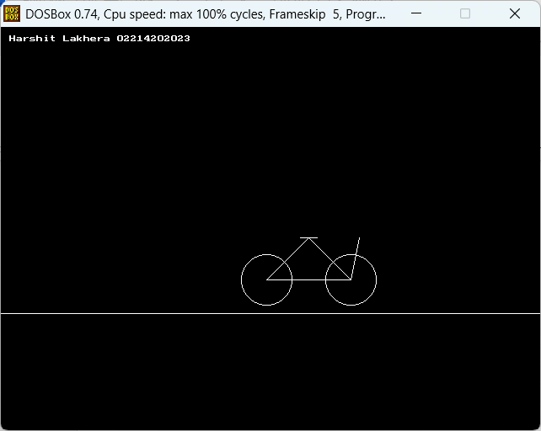

**PRACTICAL 3**

**Write a program using pre-defined functions in computer graphics to draw a night sky and stars flickering**

**Code:**

#include <dos.h>

#include <stdlib.h>

#include <graphics.h>

#include <conio.h>

void main()

{

int gd = DETECT, gm;

int i, x, y, j;

int carX = 400;

int roadY = 375;

initgraph(&gd, &gm, "C:\\TURBOC3\\BGI");

while (!kbhit())

{

cleardevice();

// Building 1 (Blue)

setcolor(WHITE);

setfillstyle(SOLID_FILL, LIGHTBLUE);

rectangle(80, 250, 130, 350); // aligned base

floodfill(81, 251, WHITE);

line(80, 250, 105, 220);

line(130, 250, 105, 220);

setfillstyle(SOLID_FILL, YELLOW);

rectangle(90, 270, 100, 290);

floodfill(91, 271, WHITE);

rectangle(110, 270, 120, 290);

floodfill(111, 271, WHITE);

// Building 2 (Gray)

setfillstyle(SOLID_FILL, LIGHTGRAY);

rectangle(150, 230, 200, 350);

floodfill(151, 231, WHITE);

line(150, 230, 175, 200);

line(200, 230, 175, 200);

setfillstyle(SOLID_FILL, YELLOW);

rectangle(160, 260, 180, 280);

floodfill(161, 261, WHITE);

rectangle(160, 300, 180, 320);

floodfill(161, 301, WHITE);

// Building 3 (Green)

setfillstyle(SOLID_FILL, GREEN);

rectangle(220, 270, 280, 350);

floodfill(221, 271, WHITE);

line(220, 270, 250, 230);

line(280, 270, 250, 230);

setfillstyle(SOLID_FILL, YELLOW);

rectangle(230, 290, 245, 305);

floodfill(231, 291, WHITE);

rectangle(255, 310, 270, 325);

floodfill(256, 311, WHITE);

// Building 4 (Cyan)

setfillstyle(SOLID_FILL, CYAN);

rectangle(300, 280, 360, 350);

floodfill(301, 281, WHITE);

line(300, 280, 330, 250);

line(360, 280, 330, 250);

setfillstyle(SOLID_FILL, YELLOW);

rectangle(310, 300, 320, 315);

floodfill(311, 301, WHITE);

rectangle(340, 320, 350, 335);

floodfill(341, 321, WHITE);

// Road boundaries and markers

setcolor(WHITE);

line(50, 350, 670, 350);

line(50, 400, 670, 400);

for (j = 0; j <= 600; j += 30)

line(50 + j, roadY, 70 + j, roadY);

// Draw white stars in the sky

for (i = 0; i < 50; i++)

{

x = rand() % getmaxx();

y = rand() % 240; // sky region (top of screen)

putpixel(x, y, WHITE);

}

// Sun/moon

setfillstyle(SOLID_FILL, WHITE);

circle(550, 70, 30);

floodfill(550, 70, WHITE);

// Car body

setcolor(RED);

setfillstyle(SOLID_FILL, RED);

rectangle(carX, roadY - 17, carX + 60, roadY);

floodfill(carX + 1, roadY - 16, RED);

// Car roof

setcolor(BLUE);

setfillstyle(SOLID_FILL, BLUE);

rectangle(carX + 20, roadY - 30, carX + 40, roadY - 17);

floodfill(carX + 21, roadY - 29, BLUE);

// Car wheels

setcolor(WHITE);

circle(carX + 15, roadY, 7);

floodfill(carX + 15, roadY, WHITE);

circle(carX + 55, roadY, 7);

floodfill(carX + 55, roadY, WHITE);

setcolor(WHITE);

outtextxy(10, 10, "Harshit Lakhera 02214202023");

delay(150);

}

getch();

closegraph();

}

**OUTPUT:**

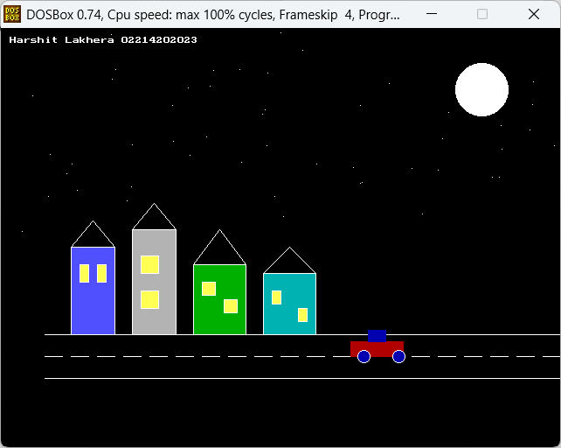

**PRACTICAL 4**

**Write a program in C to draw our tri-color national flag.**

**Code:**

#include <graphics.h>

#include <conio.h>

void main()

{

int gd = DETECT, gm;

int cx = 250, cy = 160, r = 15;

int i;

int x_offsets[24] = {15, 14, 11, 7, 3, 0, -3, -7, -11, -14, -15, -14, -11, -7, -3, 0, 3, 7, 11, 14, 15, 14, 11, 7};

int y_offsets[24] = {0, 7, 11, 14, 14, 15, 14, 14, 11, 7, 0, -7, -11, -14, -14, -15, -14, -14, -11, -7, 0, 7, 11, 14};

initgraph(&gd, &gm, "C:\\TURBOC3\\BGI");

setcolor(WHITE);

rectangle(150, 100, 350, 220);

setfillstyle(SOLID_FILL, LIGHTRED);

rectangle(151, 101, 349, 140);

floodfill(160, 120, WHITE);

setfillstyle(SOLID_FILL, WHITE);

rectangle(151, 141, 349, 180);

floodfill(160, 160, WHITE);

setfillstyle(SOLID_FILL, GREEN);

rectangle(151, 181, 349, 219);

floodfill(160, 200, WHITE);

setcolor(BLUE);

circle(cx, cy, r);

for (i = 0; i < 24; i++)

{

line(cx, cy, cx + x_offsets[i], cy + y_offsets[i]);

}

setcolor(WHITE);

rectangle(148, 101, 152, 400);

setfillstyle(SOLID_FILL, WHITE);

floodfill(149, 102, WHITE);

outtextxy(10,10,"Harshit Lakhera 02214202023");

getch();

closegraph();

}

**OUTPUT:**

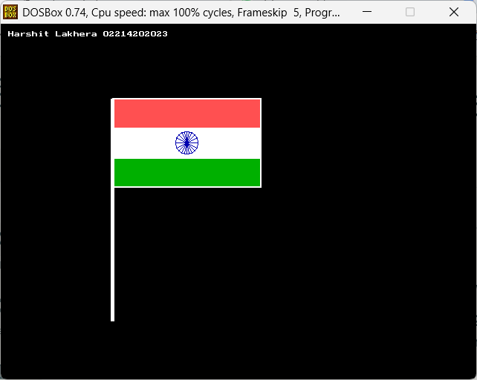

**PRACTICAL 5**

**Draw concentric circle on screen**

**Code:**

#include <graphics.h>

#include <conio.h>

void main()

{

int gd = DETECT, gm;

int cx = 320, cy = 200;

int r, color

initgraph(&gd, &gm, "C:\\TURBOC3\\BGI");

for(r = 320; r >= 20; r -= 20)

{

color = ((r / 20 - 1) % 15) + 1;

setfillstyle(SOLID_FILL, color);

fillellipse(cx, cy, r, r);

}

outtextxy(10,10,"Harshit Lakhera 02214202023");

getch();

closegraph();

}

**OUTPUT:**

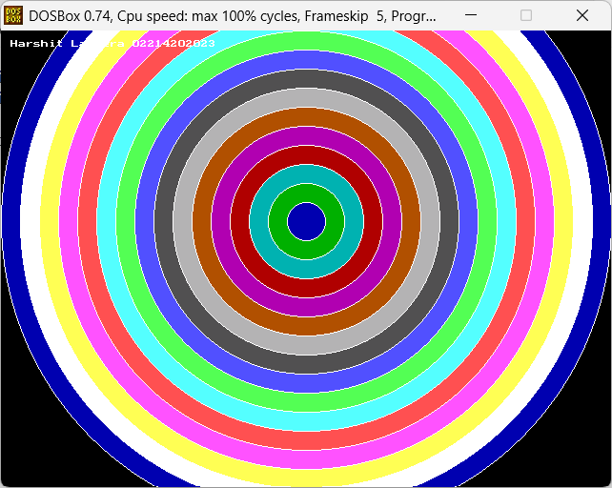

**PRACTICAL 6**

**Show changing radius of circle**

**Code:**

#include <graphics.h>

#include <conio.h>

#include <dos.h>

void main()

{

int gd = DETECT, gm;

int cx = 250, cy = 160;

int r;

initgraph(&gd, &gm, "C:\\TURBOC3\\BGI");

for(r = 10; r <= 150; r += 5)

{

cleardevice();

setcolor(WHITE);

circle(cx, cy, r);

delay(100);

}

for(r = 150; r >= 10; r -= 5)

{

cleardevice();

setcolor(WHITE);

circle(cx, cy, r);

delay(100);

}

getch();

closegraph();

}

**OUTPUT:**

